



# Charles Christopher Hyland

# 450411920



# **Table of Content**

**Section 1: Data Understanding**

Section 1.1: Data Exploration

Section 1.2: Data Quality Verification

**Section 2: Data Preparation**

Section 2.1: Data Selection

 Section 2.2: Data Preparation

# **Data Understanding**

## Data Exploration

**Data Exploration Report**

The data comes in as a tabular format, which contains 12 attributes.

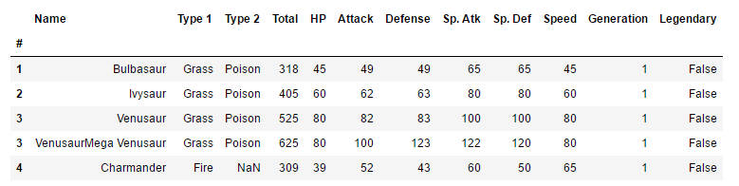

Fig. 3 Snapshot of sample of data.

Here, in a snapshot of the data, we can see it is organized in a table format. Furthermore, if a Pokémon does not have a second type, then NaN is used in place. The “Legendary” attribute return False if the Pokémon is not a legendary type Pokémon and returns True if it does.

The variables present in the data and its respective type is as follow:

|  |  |
| --- | --- |
| **Variable** | **Type** |
| Type 1 | String |
| Type 2 | String |
| Total | Numeric |
| HP | Numeric |
| Attack | Numeric |
| Defence | Numeric |
| Special Attack | Numeric |
| Special Defence | Numeric |
| Speed | Numeric |
| Generation | Numeric |
| Legendary | Boolean |

**Fig 4. List of variables**

The binary variable of Legendary will have to be converted into a numerical binary format (0 for False and 1 for True) to make data manipulation easier. Generation is coded as a numeric range from 1-6, where each number indicates a different region.

The attributes that seem most promising from the data in terms of using to classify Pokémon are:

* Attack
* Defence
* Special Attack
* Special Defence
* Speed

The generation (the region in which the Pokémon comes from) of the Pokémon currently seems irrelevant. However, it may be the case that Pokémon of a certain type from a particular region, has a combination of features which differ to Pokémon of the same type in other regions.

 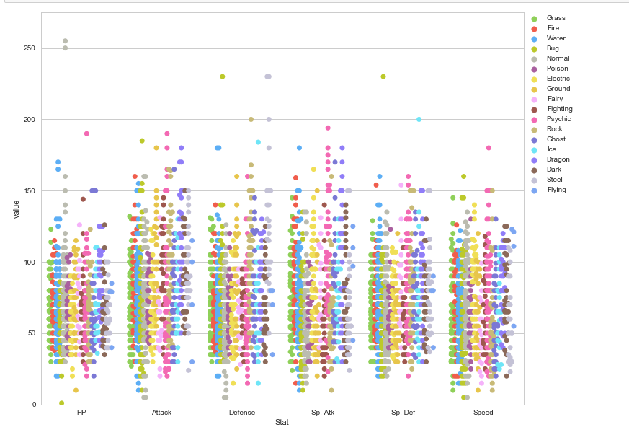



**Amount of data**

Having a large data set ensures a more accurate model and gives us more information. However, the drawback to this is that the processing time with Python will be longer due to the polynomial complexity of many algorithms to be implemented in the model.

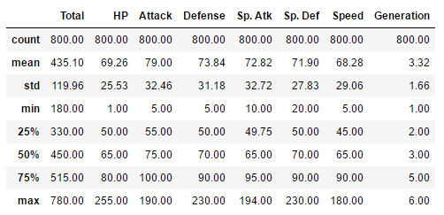

**Fig 5. Summary statistics of the data**

We can also noticed that the mean is greater than the median for the attributes of the Pokémon, thereby suggesting that the distribution of such variables are positively or right skewed.

Currently, the summary statistics of the overall data does not provide us any insights into the business problem. We would be able to derive more information by breaking down the dataset by Pokémon type.

When splitting the data up by the type of Pokémon and summarizing the data based on certain variables, a few noticeable results appeared:

|  |  |  |  |  |
| --- | --- | --- | --- | --- |
| **Variable** | **Maximum** | **Type** | **Minimum** | **Type** |
| Attack | 112.13 | Dragon | 70.97 | Bug |
| Defence | 126.37 | Steel | 65.71 | Fairy |
| Special Attack | 96.84 | Dragon | 53.87 | Bug |
| Special Defence | 88.84 | Dragon | 62.75 | Ground |
| Speed | 102.5 | Flying | 55.26 | Steel |

From this, it appears that certain Pokémon types are associated with certain characteristics and due to the discrepancies between the maximum and minimum value for each type, it is worthwhile to assume that different types of Pokémon have unique attributes associated with them. From this, we are able to proceed with the business question and makes it worthwhile to further examine this trend.

With the

## Data Verification Report

**Data Quality Report**

# Data Preparation

**Data Selection**

**Data Cleansing**

**Data Construction**

**Data Integration**

**Data Formatting**

**Dataset Description**

## Data Understanding

**Collecting Initial Data**

The data comes from existing data scraped over numerous websites via APIs. No other data is required for the project at this stage.

Currently, there are 800 observations from a cross-sectional dataset. From this it appears that the data allows us to draw generalizable conclusions and also assists us in making accurate predictions.

However, a possible issue is that there are not many attributes. This may be a problem as our predictions may suffer from omitted variable bias and that important predictors we could be using are not present in the data.

The data has already been merged and pre-processed. This brings into question the veracity of the data as the data has been processed by other parties and it is uncertain whether strict data processing methodology was adhered to.

Any missing value issues in the data was rectified as follows:

1. Find out the type of Pokémon it is.
2. Calculate the median of the attribute that the missing value belongs to from the rest of the Pokémon of the same type.
3. Use the median to replace the missing value.

It is worth acknowledging the flaws in this methodology, yet it is sufficient for the task at hand.